



15 Ways to Enjoy Non-Starchy Vegetables

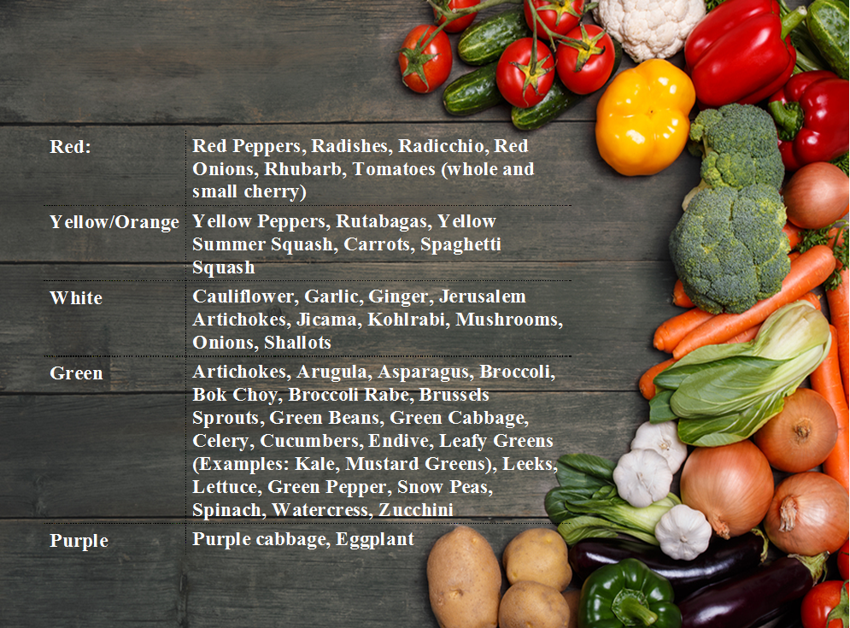

x

***Janet Sanders, J.D., C.H.C.***

***Certified Health Counselor, Blood Sugar & Diabetes Coach  
Founder, Great Life, Inc. & Blood Sugar Central™  
www.BloodSugarCentral.com***

**15 Ways to Enjoy Non-Starchy Vegetables**

**Cautionary Note**: Blood Sugar Central programs and e-books are designed to promote awareness about blood sugar and diabetes control and to provide information, tools and techniques that will enable individuals to make healthy lifestyle changes.

The coaching techniques are not intended to replace medical advice or to address any individual’s specific medical problem(s). **Always seek the advice of a physician before beginning any diet, exercise, or nutritional program**. Diabetes and pre-diabetes are serious medical conditions. It is important that program participants do not reduce, change or discontinue any medication or treatment without consulting their physician.

©2020, Great Life, Inc. & Janet Sanders, All Rights Reserved

No part of this report may be reproduced, stored in a retrieval system, or transmitted

by any means without the written permission of the author.

Table of Contents

Non-Starchy Vegetable Primer 4

Benefits of Non-Starchy Vegetables 4

Choosing Non Starchy Vegetables 4

Is Edamame a bean, legume or vegetable? 5

What About Buying Organic? 5

15 Ways to Enjoy Non-Starchy Vegetables 6

 It’s a Snap! 6

 Pretty Easy 7

 Hmm…Looks a Little Harder 9

 I Hate to Cook,but I’ll eat it if *you* make it. 9

# Non-Starchy Vegetable Primer

## Benefits of Non-Starchy Vegetables

Non-starchy vegetables are the cornerstone of your food plan for a number of reasons stated below:

* They are low glycemic and generally contain both fiber and smaller amounts of carbohydrate per serving.
* They are nutrient dense. This means that they are an excellent source of fiber, vitamins, minerals, antioxidants(substances that protect the body by neutralizing fee radicals) and phytochemicals (bioactive compounds in plants that give them their color and flavor and provide many health benefitis associated with eating vegetables.)
* Damage to the cells inside our body leads to complications.. Vegetables are one of the most powerful defences against complications and a plentiful intake of non-starchy vegetables is highly recommended for all people with diabetes both for blood sugar management and avoiding complications associated with diabetes and chronic high blood sugars.
* As you incorporate more vegetables into your food plan, you will naturally "crowd out" foods that spike your blood sugar levels. It is much easier to eliminate foods that don't serve your best health interests by "crowding them out" with foods that do, as opposed to hunkering down with willpower to try to stop eating foods you crave.

## Choosing Non Starchy Vegetables

* For optimum health, try to include 5-9 servings daily. To get the most health benefits from eating vegetables, eat both raw and cooked vegetables and include a rainbow of colors. Include leafy dark greens daily.
* The best choices are fresh, frozen and canned vegetables and vegetable juices without added sodium,. If using canned or frozen vegetables, look for ones that say low sodium or no salt added on the label. As a general rule, frozen or canned vegetables in sauces are higher in both fat and sodium. If using canned vegetables with sodium, drain the vegetables and rinse with water. Then cook the rinsed vegetables in fresh water. This will cut back on how much sodium is left on the vegetables.

|  |  |
| --- | --- |
| Red: | Red Peppers, Radishes, Radicchio, Red Onions, Rhubarb, Tomatoes (whole and small cherry) |
| Yellow/Orange | Yellow Peppers, Rutabagas, Yellow Summer Squash, Carrots, Spaghetti Squash |
| White | Cauliflower, Garlic, Ginger, Jerusalem Artichokes, Jicama, Kohlrabi, Mushrooms, Onions, Shallots |
| Green | Artichokes, Arugula, Asparagus, Broccoli, Bok Choy, Broccoli Rabe, Brussels Sprouts, Green Beans, Green Cabbage, Celery, Cucumbers, Endive, Leafy Greens (Examples: Kale, Mustard Greens), Leeks, Lettuce, Green Pepper, Snow Peas, Spinach, Watercress, Zucchini |
| Purple | Purple cabbage, Eggplant |

## Is Edamame a bean, legume or vegetable?

Edamame bean is a preparation of immature soybeans in the pods that are boiled or steamed and then served plain, with salt or other seasoning/dipping sauce. There is some debate about whether it is considered a bean/legume or vegetable, but one thing experts agree on is the powerful health punch eating just ½ cup of edamame offers.

½ cup of edamame gives you a bunch of fiber: 9 grams, about the same amount you'll find in 4 4 cups of steamed zucchini. It has almost as much protein as it does carbohydrate. It contains around 10% of the Daily Value for two key antioxidants; vitamins C and A.

## What About Buying Organic?

* Using organic foods will help to avoid the growing list of additives from artificial sweeteners to coloring agents that are finding their way into increasingly overly processed commercialized foods
* You can go to www.foodnews.org to see a full list of fruits and vegetables and their ranking in terms of level of pesticides. Generally, when budget is a consideration, try to purchase organic for foods that are high in pesticides.
* Among the cleanest are onions, avocado, sweet corn (frozen), mango, kiwi fruit, asparagus, frozen sweet peas, cabbage, eggplant & broccoli.
* Those highest in pesticides are peaches, apples, lettuce, sweet bell peppers, celery, nectarines, strawberries, imported grapes, spinach and potatoes, imported blueberries, and kale

***To claim that a product is "100 percent Organic" (or similar statement):***

* The product must contain 100 percent organically produced ingredients, not counting added water and salt.
* To claim that a food is “Organic" (or similar statement)
* The product must contain at least 95% organic ingredients, not counting added water and salt. Must not contain added sulfites.
* May contain up to 5% of: Non organically produced agricultural ingredients which are not commercially available in organic form; and/or other substances allowed by 7 CFR 205.605.

***To claim that a product is "Made with Organic Ingredients" (or similar statement):***

* The product must contain at least 70% organic ingredients, not counting added water and salt. The product must not contain added sulfites; except that, wine may contain added sulfur dioxide in accordance with 7 CFR 205.605.
* May contain up to 30% of: non organically produced agricultural ingredients; and/or other substances, including yeast, allowed by 7 CFR 205.605.

# 15 Ways to Enjoy Non-Starchy Vegetables

If you love vegetables already and like to prepare them, this next section is like preaching to the choir, but you can always learn some new ideas!If you are on the fence or pretty much consider ketchup your daily vegetable, the next section of the primer is written both to provide you with some ideas you can get started with and some inspiration.

I have tried to include ideas that range from easy to “gourmet” so that wherever you are in the spectrum, there is something for *you*. We will be building on these ideas and exploring many more recipes and ways to incorporate vegetables into your food plan.

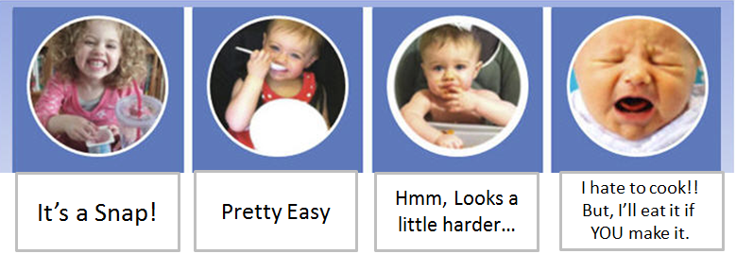

## It’s a Snap!

* ***Serve Raw Vegetables with Dip, Cheese or Favorite Spread***: You can cut them anyway you like (or buy pre-cut vegetables). Either way, find a dip or spread that you like and serve as an appetizer or eat as a snack anytime you are hungry. When in a hurry, it is perfectly OK to eat out of a zip-lock bag or paper plate. But, to really get your taste buds humming, serve them up “pretty”. Sometimes, I will cut up a bunch of different colored peppers (in larger pieces, not strips) and put them in a pretty bowl and eat them instead of chips with hummus. Ever notice if you go to a Japanese restaurant how even the simplest dish looks so appetizing because they make it “pretty”? Or, sometimes I will arrange a bunch of vegatables, my favorite cheeses and a few spreads on a pretty plate and that is a light dinner. Use your imagination. For the dips, make your own if you have time, but there are so many great pre-made dressings, dips and spreads out there, just pick one that does not have “added” sugar.
* ***Grill an Onion***: Having a barbecue and want a vegetable beyond the traditional corn on the cob or salad? Put a whole onion on the grill, (skin and all) and you are done. It is the easiest thing ever, and the result is delicious. All you need to do is turn the onion once in awhile. Yes, the outside will “char”, but the inside remains sweet and tender. When done, peel away the skin and put the onion slices in a bowl. We usually don’t even season them, but you could put a little Braggs Liquid Amino Acids or Lite Soy Sauce on them for extra flavor.
* ***Munch on Some Edamame:*** OK, there is some debate as to whether edamame is a legume, bean or vegetable, but it packs a powerful fiber and antioxidant punch and when you eat them from the pod, it is a very satisfying snack. Rather than use straight salt, I like to sprinkle a little “Gomashio” on my edamame. (a condiment made with unhulled sesame seets and sea salt). Japanese gomashio is made with a ratio of 18 parts sesame seeds to 1 part salt so it is not high in sodium and you get the extra nutrition benefit from the sesame seeds.
* ***Use Lettuce Leaves as substitute for Bread:*** This is easy to do with shredded chicken or any combination of protein and other sliced or sautéed vegetables. All you need here is some large lettuce leaves and your imagination***.***

## Pretty Easy

* ***Flavor Up Salad Dressing with finely chopped veggies:*** I recently visited one of my favorite Brazilian Steakhouses, and they had a dressing on the salad bar that was basically a viniegrette with little pieces of chopped vegetables in it. The vegetables gave the dressing such a great flavor.. At home when I feel like eating some plain romaine or baby lettuce with a light dressing, I add a variety of very finely chopped vegetables (carrots, peppers, onions, celery ---whatever I have on hand) and add them to a vinegrette. To keep this easy, I use a storebought dressing such as Newman’s Own Olive Oil & Vinegar or another brand with no added sugar. The only “hard” part is chopping the veggies, although you can use a food processor for that.
* ***Make Some Salsa***: Where to begin, there are so many different kinds of salsa and you can use a variety of vegetables. I am not talking about the “watery” stuff you get inh a jar. What I love is the fresh salsa that you get in good Mexican restaurants with diced tomatoes and peppers, or Italian or Indian restaurants as a condiment. And you don’t have to eat salsa with chips. Salsa’s are great as a condiment for fish, chicken other vegetables or on their own. ***Here is a basic salsa that is delicious on grilled fish***. Dice Roma tomatoes, red onion, basil in pretty small pieces. Combine with minced garlic extra virgin olive oil a little salt, (and if desired a touch) of balsamic vinegar. Allow to sit for about an hour before serving. That’s it, and so good.
* ***Use Frozen Vegetables for Easy Salads and Side Dishes:*** I always have petite frozen peas in my freezer. From easy pea salads to soup and mixing into cauliflower rice, they are so versatile and only take minutes to cook. Here is my go-to pea salad: Put peas in colander and run under really hot water (yes, you can do that, you don’t really need to cook frozen peas), dice some red onion & water chestnuts and add to peas. Then season with rice vinegar, mirin and a little Braggs Liquid Amino Acids. Another great combination is cauliflower rice, peas and sautéed onions. More good news, I like to make my own cauliflower rice, but now Trader Joe’s has it in their frozen section.What could be easier!.Check out the frozen section in your favorite store and see what appeals to you.
* ***Lightly steam or boil some Kale:*** Kale contains seven times the beta carotene of broccoli and ten times as much lutein and zeaxanthin. These are eye protecting carotenoids that are known to protect against macular degeneration. Most people are familiar with garden variety greens such as spinach and romaine lettuce, but shy away from other varieties of greens such as arugula, kale, bok choy, collards and mustard greens. You can eat kale on its own or there are a number of delicious ways to enjoy it:
  + Lightly boil some kale, chop it up finely and add it to some cooked quinoa. (such as barley or quinoa) For variety add other chopped vegetables or sun-dried tomatoes.
  + Add some cooked chopped kale to your regular salad.
  + Add some kale to soups such as minestrone
  + Lightly sauté some kale in olive oil. Add pine nuts and minced garlic for extra flavor.
  + Lightly boil kale. Chop finely and sprinkle with rice vinegar. For extra flavor sprinkle on some Gomashio. ( a seasoning made of ground sesame seeds and other spices)
* ***Make a soup with leftover vegetables***: You can puree leftover broccoli, cauliflower, carrots with some sautéed onions and mix with low-fat milk or almond milk with seasonings (try nutmeg) for a fast creamy soup
* ***Make a cucumber salad***: Here is a basic recipe: Slice cucumbers thinly. (The easiest way is to use a hand held mandoline. I own one made by Kyocera and it is invaluable for preparing vegetables quickly

.NOTE: The blade is very sharp, ALWAYS use the guard that comes with the mandoline or wear a protective glove.



Next pour rice vinigar (use a brand withoug added sugar) over the cucumbers.

Next: season with a little Mirin and/or Bragg Liquid Amino All Purpose Seasoning to taste.

Alternatively you could season the cucumbers with Ponzu Sauce (an Asian seasoning that is a combination of Rice Vinegar, Mirin and Tamari) (use the liquid sparingly and season to taste)



That’s it. Could not be easier.

Traditionally, sugar is added to cucumber salad. That is where the Mirin comes in. It is a Japanese rice cooking wine that adds a touch of sweetness. (purchase a brand with no added sugars, such as Eden brand).

I prepare a batch of this salad at the beginning of the week and eat it for a snack or as a side salad throughout the week.

## Hmm…Looks a Little Harder

* ***Roast a Variety of Vegetables***: If you don’t care much for vegetables,nothing brings out the “yummy” like roasting them with high quality olive oil, and fresh seasonings. Making roasted vegetables is easy to do, but it does take a little time. Here is the basic preparation method:**Cut Vegetables in Desired Shape & Size + Coat with Oil & Seasonings + Roast+[Add garnishes, if desired, such as toasted pecans]. Full Recipes coming in upcoming posts...**
* ***Press Some Purple or Green Cabbage***: Pressing cabbage is a method of “cooking” cabbage without heat. Basically, you slice it thin, put it in a large bowl, mix in some salt, which draws out water and makes the cabbage sweeter and easier to digest. You press it by putting something heavy over the cabbage while it is in the bowl (I use a small plate with a little weight that I got at the dollar store). Then you rinse off excess salt and season it. (I often lightly season it with rice vinegar). You can eat it plain, sprinkle on salads or use it in a stir fry. You can also make a variety of coleslaws with it. I make a batch of pressed cabbage on the weekend, store it in the fridge and when I want something crunchy, instead of chips, I eat pressed cabbage plain, right out of the container. It also really zips up a plain salad or is great as a condiment for Chinese Chicken Salad.

## I Hate to Cook,but I’ll eat it if *you* make it.

* ***Substitue Cauliflower Rice for White or Brown Rice***

If you are trying to cut back on rice, using versatile cauliflower is a great substitution. Don’t expect it to taste like rice. But, the texture when cooked properly gives you the “rice” experience and it really does taste great. I like it best when the cauliflower rice is mixed with diced sautéed onions. Then you can add any garnishes or additional vegetables (for example, peas) as shown in the picture below.

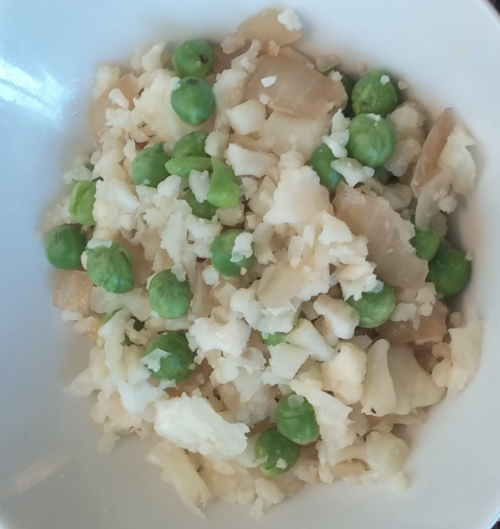

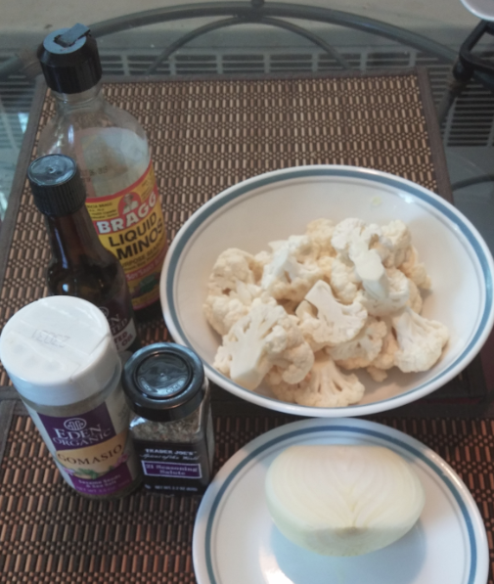

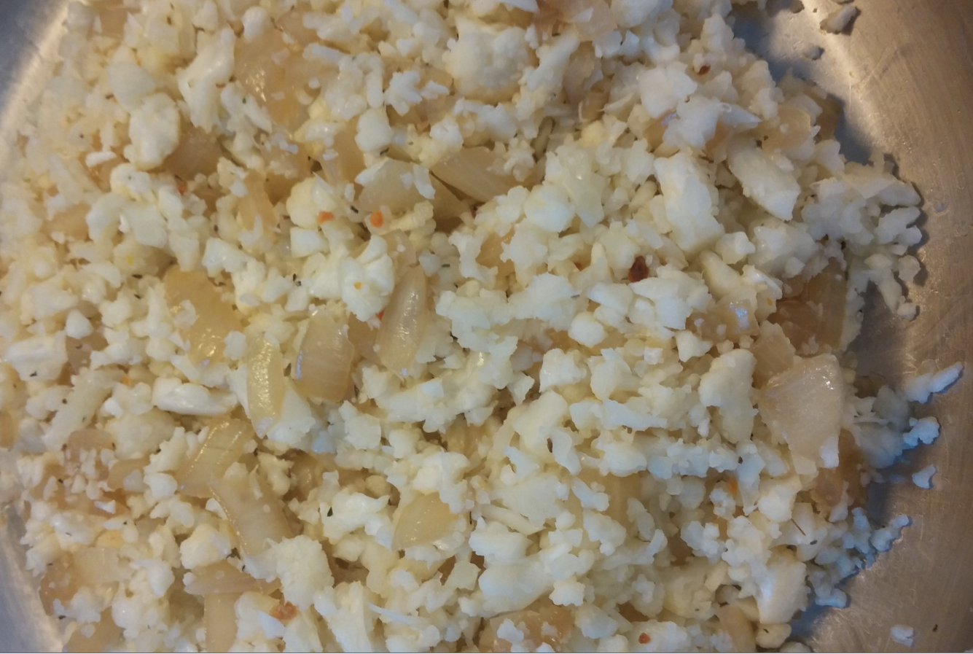

**Preparation:**

**Chop Cabbage + Lightly Steam + Press out liquid+ Prepare othe Vegetables + Saute + Season + Add Condiments**

* + Cut one head of cauliflower in half and cut the florets off from core
  + Break up the florets into somewhat evenly sized pieces
  + Place florets in bowl of food processor in batches. Process until evenly chopped but not completely pulverized. ( I use a Vitamix for this step using the pulse feature and pulse the contents until they are reduced to the size of couscous or rice grains.)
  + Next saute diced onions in olive oil (or coconut oil) until translucent. Season lightly with Braggs Liquid Aminos (or seasoning of choice) to bring out sweetness in onions
  + Stir in the cauliflower "rice" into the pan with the onions, mixing the ingredients thoroughly.
  + Lower the heat to medium, cover the pan, and cook until the cauliflower is tender, 5 to 8 minutes. (Don’t overcook. Cauliflower should be cooked but still slightly crunchy.
  + Optional:season with mix such as Trader Joe’s 21 Salute or add Gomashio for flavoring- a mixture of sea salt and sesame seeds
  + If desired garnish with other vegetables, nuts or sunflower seeds. I like to add cooked petite peas to the mix.
* ***Try some Vegetable Pasta: Zucchini Noodles with olive oil, roasted tomatoes and sautéed onions***

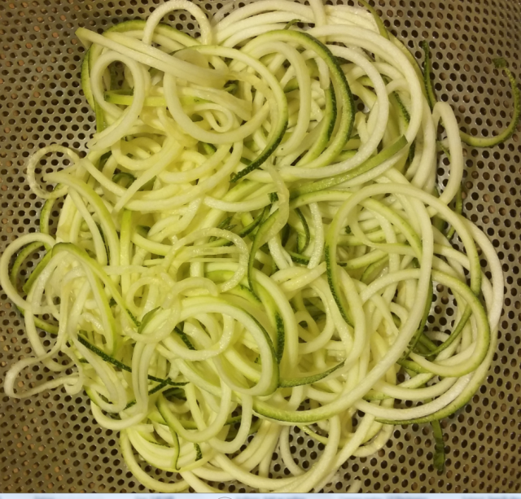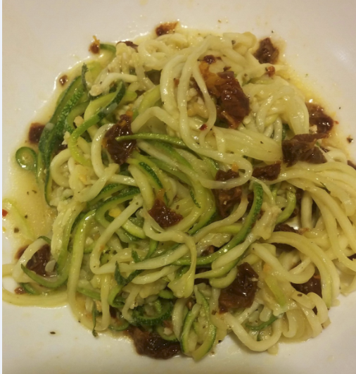

**Basic Preparation: Make “noodles” using sprializer + Prepare other vegetables or protein as desired+ Saute or Steam the “noodels” + Mix with vegetables and/or sauce +Garnish and/or Sprinkle with Parmesan Cheese**

* + Make the Noodles: cut the Zucchini with a spiralizer, a mandolin fitted with a julienne attachment, or shaved thinly with a peeler.
  + Saute the Onions: Dice onion (approximately 1 cup). Saute in olive oil until translucent. Season with a small amount of Braggs Liquid Amino Acids while cooking. (goal is not to make onions salty, but to use a small amount of the Braggs to bring out the sweetness of the onions.)
  + Saute the Zucchini Noodles Heat a large skillet over medium-high with a few tablespoons of Olive Oil.  Add the Zucchini and toss to coat in Oil..
  + Prepare Sun Dried Tomatoes: Chop sundried tomatoes packed in olive oil into small pieces (or purchase them already cut into smaller pieces)
  + Add Tomatoes and Onions: Add sundried tomatoes and onions to skillet with zucchini noodles. Stir gently into the zucchini..
  + Garnish and Servie: Place noodles into a serving bowl. If desired, sprinkle with parmesan cheese.

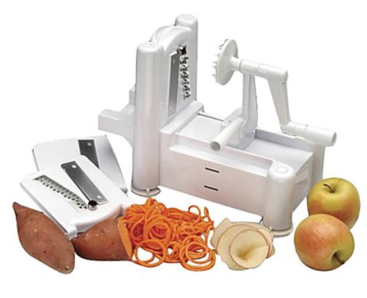

The Spiralizer is one of my favorite kitchen tools. They usually come with 3 blades so that you can make different shaped vegetable or fruit noodles and shavings.You can get a good spiralizer for $25-$40.

## 

* ***Make a mini pizza with cauliflower crust:*** I have just discovered the “miracle” of pizza I can actually eat with ZERO guilt.   
    
  Now, I am not going to tell you that the crust is the same as the chewy Italian stuff, but I have to say, I really liked the pizza with cauliflower crust a lot. With the tomato sauce, cheese and toppings, it was a delicious pizza experience, and it was fun to eat as much as I wanted.   
    
  There are some good recipes for this on the web, and I will have one for you in the in upcoming posts.

